Experiment-I: Java Program to create TCP Sockets for C/S Communication
- Create a java project (Ex: kalpana1)

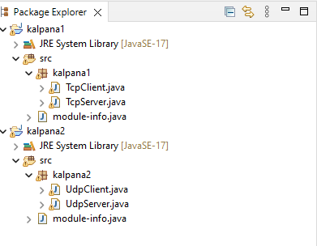

- Create a new class TcpServer - Write the code for server program and save it

package kalpana1;
import java.io.*;
import java.net.*;
public class TcpServer {

public static void main(String[] args) throws Exception{
// TODO Auto-generated method stub
ServerSocket ss=new ServerSocket(8088);
System.out.println("server is ready!");
Socket ls=ss.accept();
System.out.println("Client Port is "+ls.getPort());
//READING DATA FROM CLIENT
InputStream is=ls.getInputStream();
byte data[]=new byte[50];
is.read(data);
String mfc=new String(data);
//mfc: message from client
System.out.println("Message from client :"+mfc);
mfc=mfc.trim();
String mfs="Hello "+mfc;
//SENDING MSG TO CLIENT
OutputStream os=ls.getOutputStream();
os.write(mfs.getBytes());
}
}

- Create one more class TcpClient - Write the code for client program and save it

package kalpana1;
import java.io.*;
import java.net.*;
public class TcpClient {

public static void main(String[] args) throws Exception{
// TODO Auto-generated method stub
System.out.println("connecting to server");
Socket cs=new Socket("localhost",8088);
BufferedReader br=new BufferedReader(new InputStreamReader( System.in));
System.out.println("The Local Port "+cs.getLocalPort()+"\nThe Remote Port"+cs.getPort());
System.out.println("The Local socket is "+cs);
System.out.println("Enter your name");
String str=br.readLine();
//SENDING DATA TO SERVER
OutputStream os=cs.getOutputStream();
os.write(str.getBytes());
//READING DATA FROM SERVER
InputStream is=cs.getInputStream();
byte data[]=new byte[50];
is.read(data);
//PRINTING MESSAGE ON CLIENT CONSOLE
String mfs=new String(data);
mfs=mfs.trim();
System.out.println("Message from Server: " +mfs);
}
}

- Run the server program first (but don’t close)
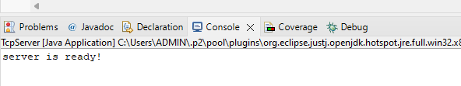

- Move to client program and run the client now
- As soon as we run client, we will see this at server console (indicates communication has been established between client and server, along with client port no)
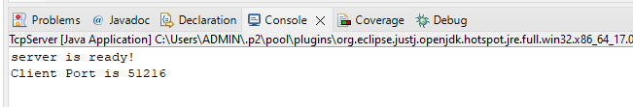
- Now switch to client console
- It will prompt to enter the name:
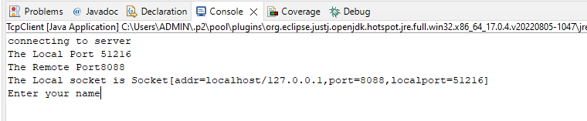
- As soon as we enter name, it will be sent to server and we will receive a message from server back:
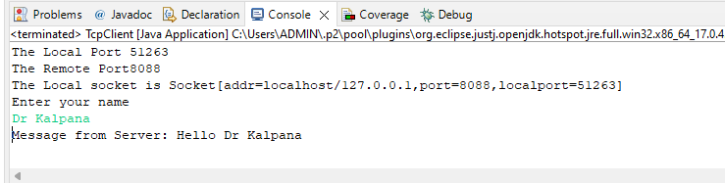
- Go back to check whether message was sent to server or not, by opening server console:
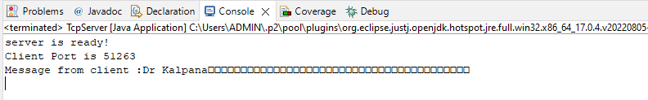
Experiment-II: Java Program to create UDP Sockets for C/S Communication
- Create a java project (Ex: kalpana2)
- Create a new class UdpServer - Write the code for server program and save it

package kalpana2;
import java.net.*;
public class UdpServer {
public static void main(String[] args) throws Exception{
byte buff[]=new byte[1024];
DatagramSocket ds =new DatagramSocket(8088);
DatagramPacket p=new DatagramPacket(buff,buff.length);
System.out.println("Server ready :");
ds.receive(p);
String msg = new String( p.getData(),0,p.getLength()).trim();
String str = "Hello "+new String(buff);
buff = str.getBytes();
ds.send(new
DatagramPacket(buff,buff.length,InetAddress.getLocalHost(),8089));
System.out.println("Msg received from client : "+msg);
}

}

- Create one more class UdpClient - Write the code for client program and save it

package kalpana2;
import java.net.*;
import java.io.*;
public class UdpClient {
public static void main(String[] args) throws Exception {
byte[] buff=new byte[1024];
DatagramSocket ds = new DatagramSocket(8089);
DatagramPacket p=new DatagramPacket(buff,buff.length);
BufferedReader br=new BufferedReader(new InputStreamReader(
System.in));
System.out.print("Enter your name:");
String msg = br.readLine();
buff = msg.getBytes();
ds.send(new DatagramPacket(buff,buff.length,InetAddress.getLocalHost(),8088));
ds.receive(p);
msg = new String( p.getData(),0,p.getLength()).trim();
System.out.println("Msg received from server : "+msg);
}
}

- Run the server program first (but don’t close)
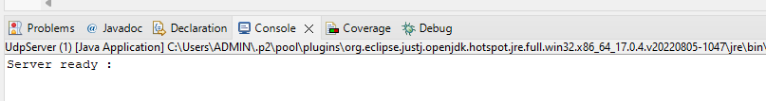
- Move to client program and run the client now
- It will prompt to enter the name:
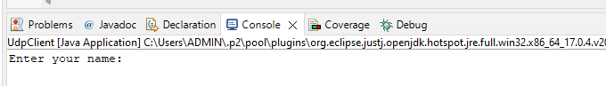
- As soon as we enter name, it will be sent to server and we will receive a message from server back:
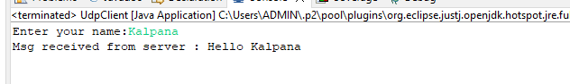
- Go back to check whether message was sent to server or not, by opening server console:
